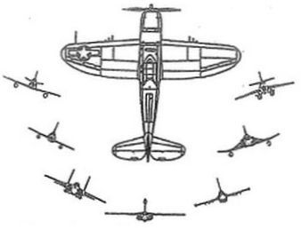
366th Fighter Association
Merchandise Order Form

Item Quantity Price

Challenge Coin _______ ______
Gunfighter Patch _______ ______
Lapel/Hat Pin _______ ______
Gunfighter Sticker _______ ______
Books _______ ______

Total Enclosed U.S. $ ________

Make Checks Payable to: 366th Fighter Association

Mail to:

366th Fighter Association
Attn: Ken Cody
193 Lynbrook St.
Henderson, Nevada 89012

